PRODUCT RENTAL APPLICATION

Group Project Report

Submitted by
UNNAMALAI S
(35224U09020)
In partial fulfillment for the award of the degree
OF
BACHELOR OF COMPUTERAPPLICATIONS
Under the Supervision of

Ms.B.KOWSALYA,M.Sc, M.phil.,

Assistant professor

352, HOLY CROSS ARTS AND SCIENCE COLLEGE FOR WOMEN
DEPARTMENT OF COMPUTER APPLICATIONS
TIRUPATTUR
TIRUPATTUR DIST–635 602
OCTOBER 2026

DECLARATION
I here by certify that the Project entitled “PRODUCT RENTAL APPLICATION” submitted by UNNAMALAI .S (35224U09020) in partial fulfillment of the requirement for the award of degree of the Bachelor of Computer Applications submitted at HOLY CROSS ARTS AND SCIENCE COLLEGE FOR WOMEN,TIRUPATTUR is an authentic record of my own work carried out during a period from 2025 to 2026 under the guidance of Miss.B.KOWSALYA,M.Sc.,M.Phil.,Assistant professor, Department of Computer Science and Applications, Holy Cross Arts and Science College for Women, Tirupattur.

Place: Tirupattur (Signature of the Student)
Date: UNNAMALAI.S

BONAFIDE CERTIFICATE

This is to certify that the project titled “PRODUCT RENTAL APPLICATION” is the bonafide record of work carried out by UNNAMALAI.S (35224U09020) in partial fulfillment of the requirement for the award of the degree of Bachelor of Computer Science submitted at HOLY CROSS ARTS AND SCIENCE COLLEGE FOR WOMEN, TIRUPATTUR. It is an authentic record of work carried out during a period from2026 to 2027 under the guidance of Miss.B.KOWSALYA, M.Sc.,M.Phil., Assistant Professor, Department of Computer Science and Application, Holy Cross Arts and Science College for Women, Tirupattur. The Major Project Viva-Voce Examination has been held on

Signature of the Guide Signature of the HOD

Internal Examiner External Examiner

ACKNOWLEDGEMENT

At the very outset I offer my sincere thanks to ALMIGHTY GOD for the grace and blessings that made me to complete the project in a successful manner.
I would also like to thank my parents and my friends gave me this life and guiding all my way to success.
As I submit the project report it gives me great pleasure to acknowledge my gratitude to various persons who were instrumental in the completion of this project.
I thankfully remember Late.Mr.S.SAMINATHAN, the founder of our college, Mrs.S.SALETTE MARY, the chairman of our college, for the everlasting support.
I would like to express my humble gratitude to our respected Dr.Major.M.RENI SAGAYARAJ, Principal Holy Cross Arts and Science College for Women, Tirupattur, for permitting me to have my project work.
I extend my heartfelt thanks to Dr.S.JULIA SELVA SUNDARI, the Secretary, for providing me an opportunity to do this dissertation and valuable advice that made me to carry out the project work successfully.
I convey my deep sense of gratitude to Mrs.C.RINIYA Head Department of Computer Science and Applications, Holy Cross Arts and Science College for Women, Tirupattur, for her valuable guidance.
I thank to my project Supervisor, Miss.B.KOWSALYA Assistant professor Department of Computer Science and Applications, Holy Cross Arts and Science College for Women, Tirupattur, for her valuable support, ideas and suggestion, which have been very helpful in completion of the project.
I grateful to all the faculty members of the Department of Computer Applications, Holy Cross Arts and Science College for Women, Tirupattur, for their extended co-operation during my project work.

TABLE OF CONTENTS
S.NO. | CONTENTS | PAGE NO
01 | ABSTRACT  INTRODUCTION  1.1 Purpose  1.2 System Overview  1.3 Existing System  1.4 Proposed System  1.5 Problem Statement  1.6 Scope of the System | 1
02 | SYSTEM REQUIREMENT SPECIFICATION  2.1 Hardware Requirements  2.2 Software Requirements  2.3 Feasibility Study  2.4 Functional and Non-Functional Requirements  2.5 Modules Description | 8
03 | SYSTEM ANALYSIS AND DESIGN  3.1 System Architecture  3.2 Use Case Diagram  3.3 Data Flow Diagram  3.4 Class Diagram  3.5 Sequence Diagram  3.6 Database Design  3.7 ER Diagram | 17
04 | SYSTEM IMPLEMENTATION  4.1 Development Environment  4.2 User Module Implementation  4.3 Administrator Module Implementation  4.4 Database and MySQL Implementation  4.5 Support and Complaint Implementation
05 | FUTURE ENHANCEMENT | 42
06 | IMPLEMENTATION  6.1 Screen Layout  6.2 Source Code | 44
07 | TESTING  7.1 Test Plan  7.2 Scope of Testing  7.3 Test Case  7.4 Functional Testing  7.5 Security Testing  7.6 Performance Testing  7.7 Usability Testing  7.8 Compatibility Testing | 61
08 | BIBLIOGRAPHY | 66
09 | CONCLUSION | 67

ABSTRACT

The Product Rental Application is a web-based application developed to provide an online platform for renting products for a specific period of time. The application is designed to connect product owners and users who need products temporarily. Instead of purchasing a product, users can search for suitable products and submit rental requests through the application. The project is developed using PHP 8, My SQL, HTML5, CSS3, JavaScript and Bootstrap 5. The application follows a lightweight Model-View-Controller (MVC) architecture. My SQL is used to store and manage user details, product information, rental requests, reviews, notifications, Wishlist and complaints. The system provides important features such as user registration, login, product listing, product search and filtering, rental request management, Wishlist, reviews and ratings, notifications and complaint management. An administrator can manage users, products, categories, rentals and complaints through the admin panel. The Product Rental Application provides a simple, organized and user-friendly method for managing rental activities. It reduces the difficulties of traditional rental processes and provides a centralized platform for both product owners and renters.

1. INTRODUCTION

The Product Rental Application is an online rental marketplace developed to simplify the process of renting products. In traditional rental systems, users may have difficulty finding suitable products, checking their availability, communicating with product owners and maintaining rental records.The proposed application provides a centralized web platform where users can create accounts, list products for rent, search available products and send rental requests. Product owners can manage their products and respond to rental requests. The application also provides wish list, review, notification and complaint management features.The system is implemented using PHP and MySQL with a lightweight MVC architecture. The application is designed to provide a secure and convenient environment for managing rental transactions and related activities.
  - Purpose
The main purpose of the Product Rental Application is to provide a convenient online platform for renting products without the need to purchase them.
The system aims to:
- Provide online product rental services.
- Allow users to register and securely login.
- Allow users to list their products for rental.
- Help users search for available rental products.
- Provide product filtering based on different criteria.
- Allow users to send rental requests.
- Allow product owners to accept or reject rental requests.
- Manage rental status throughout the rental process.
- Provide wishlist functionality.
- Allow users to provide reviews and ratings.
- Provide notifications for important rental activities.
- Provide complaint management facilities.
- Allow administrators to manage the overall application.
The system therefore helps make the rental process more organized, efficient and convenient.

1.2 System overview

The Product Rental Application is a web-based rental marketplace developed to provide an online platform for renting products for a specific period of time. The system connects product owners and users who need products temporarily. The application allows users to register and login, add products for rental, search and filter available products, view product details and submit rental requests. Product owners can manage their listed products and respond to rental requests. Users can search for rental products based on different criteria such as keyword, category, district and price range. The district-based search helps users find products available within their required district. The system also provides additional features such as wish list management, reviews and ratings, notifications and complaint management. Users can save products to their Wishlist, provide reviews after completing rentals and submit complaints when required. The administrator manages the overall application through the administrator module. The administrator can manage users, products, categories, rental requests and complaints. The Product Rental Application is developed using PHP, MySQL, HTML5, CSS3, JavaScript and Bootstrap 5. The application follows a lightweight Model-View-Controller (MVC) architecture for organizing the application components.
The main modules of the Product Rental Application are:
- User Registration and Login
- User Profile Management
- Product Management
- Product Search and Filtering
- District-Based Product Search
- Rental Request Management
- Wishlist Management
- Review and Rating Management
- Notification Management
- Complaint Management
- Administrator Management
Thus, the Product Rental Application provides a centralized, organized and user-friendly platform for managing product rental activities based on product availability and district.

1.3 Existing system
In the existing system, product rental activities are commonly handled through physical rental shops, direct communication or informal methods.
Users may need to visit rental shops or contact product owners directly to find a required product. Product availability, rental price and rental duration may not be easily accessible.
The existing system has several limitations.
Limitations of Existing System
1. Product searching is mostly manual.
2. Availability information may not be updated properly.
3. Rental records may be maintained manually.
4. Users may have difficulty comparing different products.
5. Rental requests are not centrally managed.
6. There may be difficulty tracking rental status.
7. User reviews and ratings may not be available.
8. Complaint management may not be organized.
9. Communication between renters and product owners can be difficult.
10. Manual processes require more time and effort.
These limitations create the need for an organized online rental management system.
1.4 Proposed system
The proposed system is a web-based Product Rental Application that provides a centralized platform for managing product rentals.
The application allows users to register and login, search for products, view product details and send rental requests. Users who own products can add and manage their products through the application.
The system manages the complete rental request lifecycle. A rental request initially has a pending status. The product owner can accept or reject the request. Accepted rentals can later be completed, while renters can cancel their requests when applicable.
The application also provides wishlist, reviews, ratings and notification features. Users can submit complaints, and administrators can review and manage them.

Advantages of Proposed System
- Easy online product searching.
- Centralized product information.
- Easy product listing and management.
- Rental request management.
- Availability management.
- Wishlist functionality.
- Review and rating facility.
- Notification system.
- Complaint management.
- Administrator control.
- Secure user authentication.
- Organized database management.
- User-friendly web interface.
The proposed system therefore provides a more efficient and organized alternative to traditional rental methods.
1.5 Problem statement
Traditional product rental processes can be difficult to manage because product information, availability, rental records and user details may not be maintained in a centralized system.
Users may spend more time searching for suitable products and contacting product owners. Product owners may also face difficulties in managing multiple rental requests and maintaining rental information.
The absence of a centralized system can result in:
- Difficulty in finding rental products.
- Difficulty in checking product availability.
- Difficulty in managing rental requests.
- Improper maintenance of rental records.
- Lack of organized product information.
- Difficulty in tracking rental status.
- Limited review and rating facilities.

Therefore, there is a need for a web-based system that can organize and automate major product rental activities.
The Product Rental Application addresses these problems by providing a centralized platform for users, product owners and administrators.
1.6 Scope of the system
The scope of the Product Rental Application covers the major activities required for online product rental management.
User Management
The system provides:
- User registration.
- User login and logout.
- User profile management.
- Email verification support.
- Password reset functionality.
- User account status management.
Product Management
Users can:
- Add rental products.
- Edit products.
- Delete products.
- Upload product images.
- Set rental prices.
- Set rental units.
- Specify deposit amounts.
- Specify product location.
- Manage product availability.
Product Searching
Users can search and filter products using available product information.
The application supports product discovery based on:
- Keyword
- Category
- City
- Minimum price
- Maximum price

Rental Management
The system supports:
- Rental request creation.
- Rental date selection.
- Rental amount calculation.
- Rental request acceptance.
- Rental request rejection.
- Rental cancellation.
- Rental completion.
- Rental status tracking.
The rental request status can be:
- Pending
- Accepted
- Rejected
- Completed
- Cancelled

Wishlist Management
Users can add products to their wishlist and remove them when required.
Review Management
Users can provide ratings and comments after completed rentals.
Notification Management
The system provides notifications related to important activities such as rental requests and rental status changes.
Complaint Management
Users can submit complaints related to users or products. Administrators can review complaints and update their status.
Complaint statuses include:
- Open
- In Review
- Resolved
- Dismissed

Administrator Management
The administrator can manage:
- Users
- Products
- Categories
- Rentals
- Complaints
- Site settings
Database Management
The application uses MySQL to store and manage the application's data. The database contains tables for users, categories, products, product images, rental requests, reviews, notifications, wishlists, complaints, activity logs and site settings.
Security Scope
The application includes security mechanisms such as:
- Password hashing.
- Session-based authentication.
- Authentication checks.
- Authorization checks.
- CSRF protection.
- Input validation.
- File upload validation.
Future Scope
The system can be further enhanced by adding features such as online payment, GPS-based nearby product search, real-time chat, mobile application support and AI-based customer support.

2. SYSTEM REQUIREMENT SPECIFICATION

2.1 Hardware requirements
The Product Rental Application is a web-based application and can be developed and executed using a standard computer system. The following hardware configuration is recommended for running the application smoothly.
Minimum Hardware Requirements
- Processor : Intel Core i3 or equivalent
- RAM : 4 GB or above
- Hard Disk : 10 GB or above free space
- Monitor : Standard display monitor
- Keyboard : Standard keyboard
- Mouse : Standard mouse
- Network : Internet connection for web-related activities
Recommended Hardware Requirements
- Processor : Intel Core i5 or above
- RAM : 8 GB or above
- Storage : 20 GB or above free space
- Display : 1366 × 768 resolution or above
- Network : Stable internet connection
The above hardware configuration is sufficient for developing, testing and running the Product Rental Application using XAMPP and a web browser.
2.2 Software requirements
The Product Rental Application is developed using commonly available web development technologies.
Operating System
The application can be developed and executed on:
- Windows
- Linux
- macOS

Programming Language
PHP 8 is used as the main server-side programming language. PHP handles application logic, authentication, product management, rental requests and database operations.
Database
MySQL is used as the database management system. It stores user information, product details, rental requests, reviews, notifications, wishlists, complaints and other application data.
Database Management Tool
phpMyAdmin is used to create, import, manage and monitor the MySQL database.
Front-End Technologies
The user interface is developed using:
- HTML5
- CSS3
- JavaScript
- Bootstrap 5
HTML5 provides the structure of the web pages. CSS3 is used for styling. JavaScript provides client-side interactions, while Bootstrap provides responsive user interface components.
Development Environment
XAMPP is used as the local development environment. It provides Apache and MySQL services required to execute the application.
Web Browser
The application can be accessed using modern web browsers such as:
- Google Chrome
- Microsoft Edge
- Mozilla Firefox
Code Editor
A code editor such as Visual Studio Code can be used to edit and maintain the PHP, HTML, CSS and JavaScript source code.
2.3 Feasibility study
A feasibility study is conducted to determine whether the Product Rental Application is practical and suitable for implementation. The system is evaluated based on technical, economic and operational feasibility.

2.3.1 Technical feasibility
The Product Rental Application uses technologies such as PHP, MySQL, HTML, CSS, JavaScript, Bootstrap and XAMPP. These technologies are widely used for web application development and can be executed on standard computer systems.
The application uses a lightweight MVC architecture that separates models, controllers and views. This makes the system easier to develop, maintain and modify.
Therefore, the proposed system is technically feasible.
2.3.2 Economic feasibility
The system is economically feasible because it uses several open-source and freely available technologies.PHP, MySQL, Bootstrap and XAMPP can be used without expensive software licenses. The application can also be developed using an ordinary computer system.
Therefore, the development and maintenance cost of the system is relatively low.
2.3.3 Operational feasibility
The Product Rental Application provides a simple and user-friendly interface. Users can register, login, search products, filter products by category, district and price, submit rental requests and manage their rental activities.Administrators can manage users, products, categories, rentals and complaints.The system does not require advanced technical knowledge from normal users. Therefore, the proposed system is operationally feasible.
2.4 Functional and non-functional requirements
2.4.1 Functional requirements
Functional requirements describe the major functions that the Product Rental Application must perform.
1. User Registration
The system allows new users to create an account by entering the required personal information.
2. User Login
Registered users can login using their email and password.
3. User Logout
Users can securely logout from the application.
4. User Profile Management
Users can view and update their profile information.

5. Product Management
Users can add products for rental and manage their own product listings.
The product information includes:
- Product title
- Description
- Category
- Rental price
- Rental unit
- Deposit
- District
- Availability status
- Product images
6. Product Search
Users can search for products using keywords.
7. Product Filtering
Users can filter products using:
- Keyword
- Category
- District
- Minimum price
- Maximum price
8. Rental Request
Users can select a product and submit a rental request by specifying the required rental period.
9. Rental Request Management
Product owners can accept or reject rental requests.
10. Rental Cancellation
Users can cancel applicable rental requests.
11. Rental Completion
Completed rental activities can be marked as completed in the system.
12. Wishlist
Users can add products to their wishlist and remove them when required.
13. Reviews and Ratings
Users can provide ratings and comments for completed rental activities.

14. Notifications
The system provides notifications related to important rental activities and system events.
15. Complaint Management
Users can submit complaints related to products or other users.
16. Administrator Management
The administrator can manage:
- Users
- Products
- Categories
- Rental requests
- Complaints
- Site settings
2.4.2 Non-functional requirements
Non-functional requirements define the quality and performance characteristics of the Product Rental Application.
1. Security
The system should protect user information and restrict unauthorized access. Passwords are securely stored and authenticated users are managed using sessions.
2. Usability
The application should provide a simple and understandable interface so that users can easily search products and manage rental activities.
3. Performance
The system should process user requests and database operations efficiently and provide responses within a reasonable time.
4. Reliability
The application should perform consistently and maintain correct rental and product information.
5. Maintainability
The MVC-based structure makes the source code easier to understand, modify and maintain.
6. Scalability
The system can be extended in the future with additional products, users, rental activities and new features.

7. Availability
The application should be available whenever the web server and database services are running.
8. Compatibility
The application should work correctly with commonly used modern web browsers and different screen sizes.
9. Data Integrity
The system should maintain accurate and consistent information using database relationships, validation and appropriate constraints.
2.5 Modules description
The Product Rental Application is divided into several modules. Each module performs a specific set of functions.
2.5.1 User module
The User Module manages user accounts and authentication.
- The main functions are:
- User registration
- User login
- User logout
- Email verification
- Password reset
- Profile management
- Account status management
The module ensures that only authenticated users can access protected features.
2.5.2 Product module
The Product Module manages products available for rental.
Users can:
- Add products
- Edit products
- Delete products
- Upload product images
- Set rental price
- Set rental unit
- Add deposit amount
- Select category
- Specify district
- Set availability
This module provides complete management of rental product information.
2.5.3 Search and filter module
The Search and Filter Module helps users find suitable rental products.
Users can search products using keywords and apply filters based on:
- Category
- District
- Minimum price
- Maximum price
This module helps users quickly identify products that match their requirements.
2.5.4 Rental module
The Rental Module manages the rental request process.
The main activities include:
1. Selecting a product.
2. Selecting rental dates.
3. Creating a rental request.
4. Calculating the rental amount.
5. Sending the request to the product owner.
6. Accepting or rejecting the request.
7. Cancelling the rental when applicable.
8. Completing the rental.
The rental status is maintained throughout the process.
2.5.5 Wishlist module
The Wishlist Module allows users to save products for future reference.
Users can:
- Add products to wishlist.
- View wishlist products.
- Remove products from wishlist.
This makes it easier for users to return to products they are interested in.
2.5.6 Review and rating module
The Review and Rating Module allows users to provide feedback after completing a rental.

Users can provide:
- Rating
- Comment
Reviews help provide useful feedback about rental experiences.
2.5.7 Notification module
The Notification Module provides users with information about important activities.
Notifications may be generated for events such as:
- New rental request
- Rental acceptance
- Rental rejection
- Rental cancellation
- Rental completion
- Other system activities
2.5.8 Complaint module
The Complaint Module provides a structured way for users to report issues.
Users can submit:
- Complaint subject
- Complaint description
- Related user
- Related product
Administrators can review complaints and update their status.
2.5.9 Administrator module
The Administrator Module provides centralized control over the application.
The administrator can:
- View users
- Manage users
- Manage products
- Manage categories
- View rental requests
- Manage complaints
- Manage site settings
The administrator helps maintain the overall operation of the Product Rental Application.

2.5.10 Database module
The Database Module manages application data using MySQL.
The database stores information related to:
- Users
- Categories
- Products
- Product images
- Rental requests
- Reviews
- Notifications
- Wishlists
- Complaints
- Activity logs
- Site settings
The database provides structured storage and retrieval of application information.

3.SYSTEM ANALYSIS AND DESIGN
3.1 System architecture
The Product Rental Application follows a lightweight Model-View-Controller (MVC) architecture. The architecture separates the application into different components so that the system is easier to develop, maintain and modify.
The three main components of the architecture are:
Model
The Model is responsible for managing application data and database operations. It communicates with the MySQL database and performs operations such as inserting, updating, retrieving and deleting data.
The major models used in the application include:
- User
- Product
- Category
- Rental Request
- Review
- Notification
- Wishlist
- Complaint
View
The View represents the user interface of the application. It displays information to users and provides forms and pages through which users interact with the system.
The application provides views for:
- Home page
- Login page
- Registration page
- Product listing
- Product details
- Dashboard
- Rentals
- Wishlist
- Notifications
- Admin panel
Controller
The Controller receives user requests, processes application logic and communicates between the Model and View.
The major controllers include:
- Auth Controller
- Home Controller
- Product Controller
- Rental Controller
- Dashboard Controller
- Wishlist Controller
- Admin Controller
MVC Working Process
The basic working process is:
User → View → Controller → Model → MySQL Database
The Model returns the required data to the Controller, and the Controller sends the processed information to the View for displaying to the user.

SYSTEM ARCHITECTURE

USER / ADMINISTRATOR
↓
VIEW LAYER
HTML / CSS / JavaScript / Bootstrap
↓
CONTROLLER LAYER
Auth Controller / Product Controller / Rental Controller / Admin Controller
↓
MODEL LAYER
User / Product / Category / Rental Request / Review / Wishlist / Notification / Complaint

MYSQL DATABASE

3.2 Use case diagram
A Use Case Diagram represents the interaction between users and the Product Rental Application. It identifies the major actors and the functions they can perform.
Actors
The main actors in the system are:
1. User
2. Administrator

3.3 DATA Flow Diagram
A Data Flow Diagram (DFD) represents the flow of information between external entities, processes and the database.
The Product Rental Application uses user and administrator inputs to process rental-related activities and store information in the MySQL database.
External Entities
The main external entities are:
- User
- Administrator
Main Processes
The main processes are:
1. User Management
2. Product Management
3. Product Search
4. Rental Management
5. Wishlist Management
6. Review Management
7. Notification Management
8. Complaint Management
9. Administrator Management
Data Store
The main data store is the MySQL Database.
Main Data Flow
User → Product Rental Application → MySQL Database
The user provides information such as registration details, product details and rental requests. The system processes the information and stores it in the database.
The database returns the required information to the application, which displays the result to the user.

3.3.1 Context level (DFD level 0)
The Context Level DFD represents the complete Product Rental Application as a single process.
0.0
Product
Rental
System
Rental Request Manage products
USER
ADMINISTRATOR

Login credentials View reports

Payment request
Confirmation
Payment Gateway

3.3.2 Level 1 dfd
The Level 1 DFD divides the Product Rental Application into major processes.
Process 1: User Management
The system receives user registration and login details and stores or verifies the information using the database.

Process 2: Product Management
The system allows users to add, edit and delete their rental products.
Process 3: Product Search
The system receives search and filter criteria and retrieves matching products based on keyword, category, district and price.
Process 4: Rental Management
The system processes rental requests, rental dates, rental amounts and rental statuses.

Process 5: Wishlist Management
The system adds or removes products from the user's wishlist.
Process 6: Review Management
The system stores ratings and comments submitted by users.
Process 7: Notification Management
The system creates and displays notifications related to application activities.
Process 8: Complaint Management
The system stores complaints submitted by users and allows administrators to manage them.

1.0
User Registration & Login
2.0
Product Management
3.0
Rental Management
4.0
Payment Processing

USER

ADMIN

Create/ create/update Rental/payment
Read/ User data rental data
Update/
User
Product create/update update
Records get/products payment
status

D1

User DB
D2

Product DB
D3

Rental DB
D3

Rental DB

3.4 Class diagram
The Class Diagram represents the static structure of the Product Rental Application. It shows the major classes, their attributes, methods and relationships.
ADMIN

Admin id
Email
Password
manageUsers(), manageProducts(), viewReports()

1
owns

manages 1—* 1—* manages

USER

User id
name
email
phone
address

register()
login()
viewProducts()
owns

PRODUCT

Product id
Title
description
price Per Day
availability

add Product() updateProduct() deleteProduct()

has —1
1—* makes

RENTAL

Rental id,
User id
Product id
Start Date
endDate

1—* belongs to
PAYMENT

Payment id,
rental id,
amount,
payment Method
status
CATEGORY

Category id
name

3.5 SEQUENCE DIAGRAM
The Sequence Diagram represents the sequence of interactions between the User, Product Rental Application and Database during a rental process.
SYSTEM
DATABASE
USER
| |
|
| |
| |
| | 1.User System: Login
| |
| |
| | 2.System Database: Check user
| |
| |
| | 3.Database System: User vali
| |
| |
| | 4.User System: Search Product
| |
| |
| | 5.System Database: Get Product
| |
| |
| | 6.User System: Request Rental
| |
| |
| | 7.System Database: Save Rental
| |
| |
| | 8.User System: Make Payment
| |
| |
| | 9.System User: Rental Confirmed

7.9 ER-Daigram

Standard ER Notation| Cardinality: 1=one, N = many

ADMIN
Admin id (pk)
Name
Email
password

manages

manages

1 1

PRODUCT
product_id (PK)
product_name
category
price
availability
description

N
RENTAL
rental_id (PK)
user_id (FK)
product_id (FK)
rental_date
return_date
status
PRODUCT
product_id (PK)
product_name
category
price
availability
description

USER
user_id (PK)
name
email
password
phone
address
register_date

includes
HAS

rents
1 N
N 1

HAS

1 1
PAYMENT
payment_id (PK)
rental_id (FK)
amount
payment_date
payment_method
payment_status
transaction_id

Legend: (PK) = Primary Key| (FK) = Foreign Key| 1/N = cardinality
8.BIBLIOGRAPHY

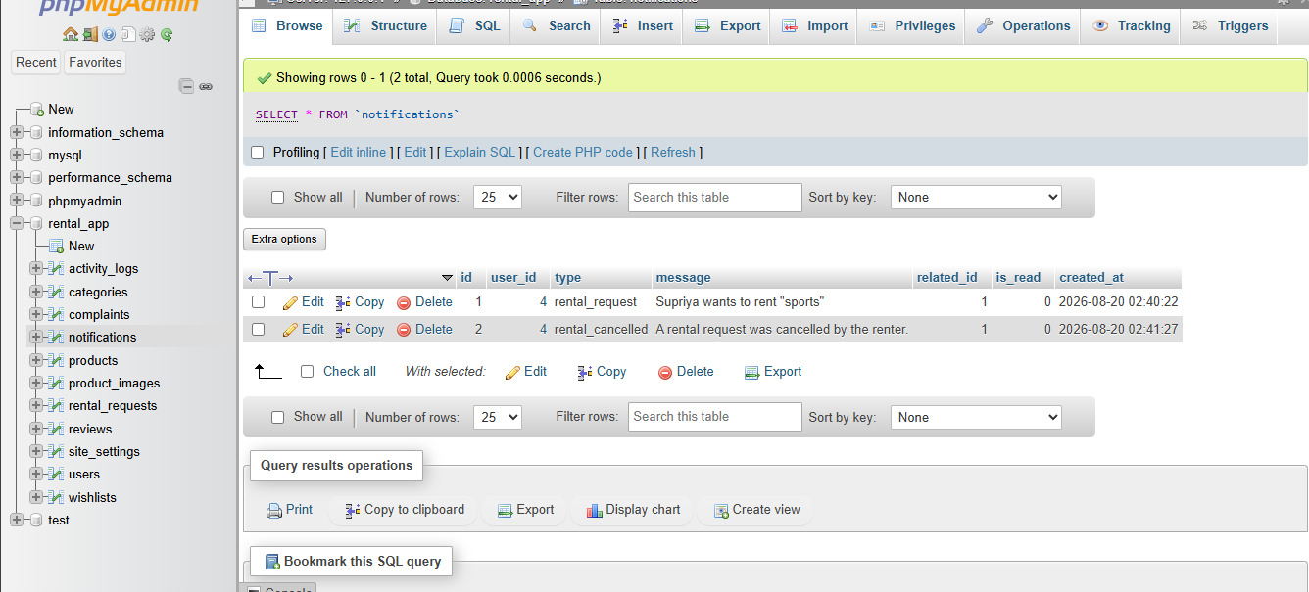
Activity Logs Table
The "activity_logs" table stores records of important user or system activities.
Site Settings Table
The "site_settings" table stores configurable application settings.

3.6.1 Database relationships
The major database relationships are:
- Users → Products: One-to-Many
- Categories → Products: One-to-Many
- Products → Product Images: One-to-Many
- Products → Rental Requests: One-to-Many
- Users → Rental Requests: One-to-Many
- Rental Requests → Reviews: One-to-One/Optional
- Users → Wishlists: One-to-Many
- Products → Wishlists: One-to-Many
- Users → Notifications: One-to-Many
- Users → Complaints: One-to-Many

4.SYSTEM IMPLEMENTATION
4.1 Development environment
The Product Rental Application is implemented as a web-based application using server-side and client-side web technologies. The development environment provides the required tools for creating, testing and executing the application.
The major technologies used in the implementation are:
- PHP 8 – Server-side programming
- MySQL – Database management
- HTML5 – Web page structure
- CSS3 – Page styling
- JavaScript – Client-side interaction
- Bootstrap 5 – Responsive user interface
- XAMPP – Local development environment
- Apache – Web server
- phpMyAdmin – Database administration
The application follows a lightweight MVC architecture, which separates application logic, database operations and user interface components.
4.2 User module implementation
The User Module is responsible for managing user accounts and authentication.
User Registration
New users can create an account by entering the required details. The registration process validates the user information and stores the account details in the MySQL database.
The registration process includes:
1. User opens the registration page.
2. User enters the required details.
3. Application validates the entered information.
4. Password is securely processed.
5. User information is stored in the database.
6. The user can login after successful registration.

User Login
Registered users can access the application using their email and password.
The login process verifies the credentials stored in the database. After successful authentication, a session is created and the user is redirected to the appropriate dashboard.
Profile Management
Users can view and update their profile information. The profile information is stored in the MySQL database.
4.3 Administrator module implementation
The Administrator Module provides centralized management of the Product Rental Application.
The administrator can manage important application data and monitor rental-related activities.
User Management
The administrator can view and manage registered users. User account status can also be controlled when required.
Product Management
The administrator can view and manage products available in the application.
Category Management
The administrator can manage product categories used for organizing rental products.
Rental Management
The administrator can view rental requests and monitor their status.
Complaint Management
The administrator can review complaints submitted by users and update the complaint status.
Site Settings
The administrator can manage application-level settings through the administration section.
The Administrator Module therefore helps maintain the proper operation of the entire system.
4.4 Database and mysql implementation
MySQL is used as the database management system for the Product Rental Application.
The database stores information required for user management, product management, rental activities and other application features.

The major tables include:
- users
- categories
- products
- product_images
- rental_requests
- reviews
- notifications
- wishlists
- complaints
Users
The users table stores user account information such as name, email, phone number, password, district and account status.
Products
The products table stores product information such as title, description, rental price, rental unit, deposit, district and availability status.
Rental Requests
The rental_requests table stores information about rental requests, including the product, renter, owner, rental dates, total amount and rental status.
Reviews
The reviews table stores ratings and comments provided by users after completed rental activities.
Notifications
The notifications table stores notifications generated for users during important system activities.
Wishlists
The wishlists table stores products saved by users for future reference.
Complaints
The complaints table stores complaints submitted by users and their current status.
The MySQL database provides structured and reliable storage for all major application information.
4.5 Support and complaint implementation
The Product Rental Application provides a complaint management facility to help users report problems related to products or other users.

Complaint Submission
A user can submit a complaint by providing relevant information such as:
- Complaint subject
- Complaint description
- Reported user
- Related product
The complaint is stored in the MySQL database.
Complaint Status
The administrator can review submitted complaints and update their status.
The complaint status can be:
- Open
- In Review
- Resolved
- Dismissed
4.6 product management implementation
The Product Management Module allows users to add and manage products that are available for rental.
Users can enter:
- Product title
- Product description
- Category
- Rental price
- Rental unit
- Deposit amount
- District
- Product images
- Availability status
- Users can also edit or delete their own product listings.
The system stores product information in the MySQL database and displays the products to other users for rental.

4.7 Rental management implementation
The Rental Management Module handles the complete rental request process.A user can select a product and enter the required rental period. The system calculates the rental amount based on the rental information and creates a rental request.The product owner can then accept or reject the request.
The main rental statuses are:
- Pending
- Accepted
- Rejected
- Completed
- Cancelled
The system updates the rental status in the database whenever an authorized action is performed.
This module helps maintain an organized record of rental activities.
4.8 Product search and filter implementation
The application provides search and filtering facilities to help users find suitable products.
Users can search products using keywords and filter the results based on:
- Category
- District
- Minimum price
- Maximum price
4.9 Wishlist implementation
The Wishlist Module allows users to save products that they may want to rent later.
Users can:
- Add a product to the wishlist.
- View saved products.
- Remove a product from the wishlist.
4.10 Review and rating implementation
The Review and Rating Module allows users to provide feedback after completing a rental.
Users can submit:
- Rating
- Comment
The review information is stored in the database and can be associated with the completed rental and reviewer.
This feature helps provide feedback about the rental experience.

4.11 Notification implementation
The Notification Module provides information about important activities performed in the application.
Notifications can be generated for events such as:
- New rental request
- Rental request acceptance
- Rental request rejection
- Rental cancellation
- Rental completion
- Other important system activities
Notifications are stored in the database and displayed to the relevant users.
4.12 Security implementation
Security is an important part of the Product Rental Application.
The application includes security mechanisms such as:
- Password hashing
- Session-based authentication
- Authentication checks
- Authorization checks
- Input validation
- CSRF protection
- File upload validation
These mechanisms help protect user accounts, application data and administrative functions from unauthorized access.

4.13 Implementation workflow
The overall implementation workflow of the Product Rental Application is:
User Registration
↓
User Login

↓
View / Search Products

↓
Filter by Category / District / Price

↓
Select Product

↓
Send Rental Request

↓
Product Owner Reviews Request

↓
Accept / Reject Request

↓
Rental Status Updated

↓
Rental Completion

↓
Review and Rating

5. FUTURE ENHANCEMENT
The Product Rental Application provides the basic facilities required for online product rental management. However, additional features can be added in the future to improve the functionality, security and convenience of the application.
5.1 Online payment integration
Online payment facilities can be integrated into the application. Users can make rental payments through secure payment methods such as UPI, debit cards and credit cards.
This feature can make the rental process faster and more convenient.
5.2 Gps and location-based search
GPS functionality can be added to help users find rental products available near their location.
The application can display products based on the user's selected or current location and district.
5.3 Real-time chat
A real-time chat feature can be implemented to allow renters and product owners to communicate directly.
Users can discuss product availability, rental details and other relevant information through the application.
5.4 Mobile application
A dedicated Android and iOS mobile application can be developed in the future.
The mobile application can provide easier access to product searching, rental requests, notifications and other services.
5.5 Advanced notification system
The notification system can be enhanced by adding email and mobile push notifications.
Users can receive instant notifications about:
- Rental requests
- Request acceptance or rejection
- Rental reminders
- Rental completion
- Complaint updates
5.6 Ai-based recommendation
An AI-based recommendation system can be introduced to recommend products based on users' previous searches, wishlist items and rental history.
This can help users find relevant products more easily.

5.7 Advanced admin dashboard
The administrator dashboard can be enhanced with charts and reports.
The dashboard can display information such as:
- Total users
- Total products
- Total rentals
- Active rentals
- Completed rentals
- Cancelled rentals
- Complaints
- Most rented products
This can help administrators monitor the performance of the application.
5.8 Document and id verification
A user verification system can be introduced to improve trust and security.
Users may be required to verify their identity before performing certain rental activities.
5.9 Product availability calendar
A calendar-based availability system can be added to show the dates on which a product is available or already rented.
This can help prevent overlapping rental requests.
5.10 Multi-language support
The application can support multiple languages in the future. This can make the system easier to use for people from different regions.
5.11 Improved security
Additional security mechanisms can be introduced to provide stronger protection against unauthorized access, fraudulent activities and malicious requests.
Regular security testing and updates can also be performed to maintain application security.

6. IMPLEMENTATION

6.1 Screen layout
The Product Rental Application provides a simple and user-friendly interface for managing product rental activities. The screen layouts are designed to make navigation and interaction easy for users and administrators.
The major screens of the application include:
6.1.1 Home page
The Home Page is the main entry point of the Product Rental Application. It provides access to product searching, user login, registration and other important sections of the application.
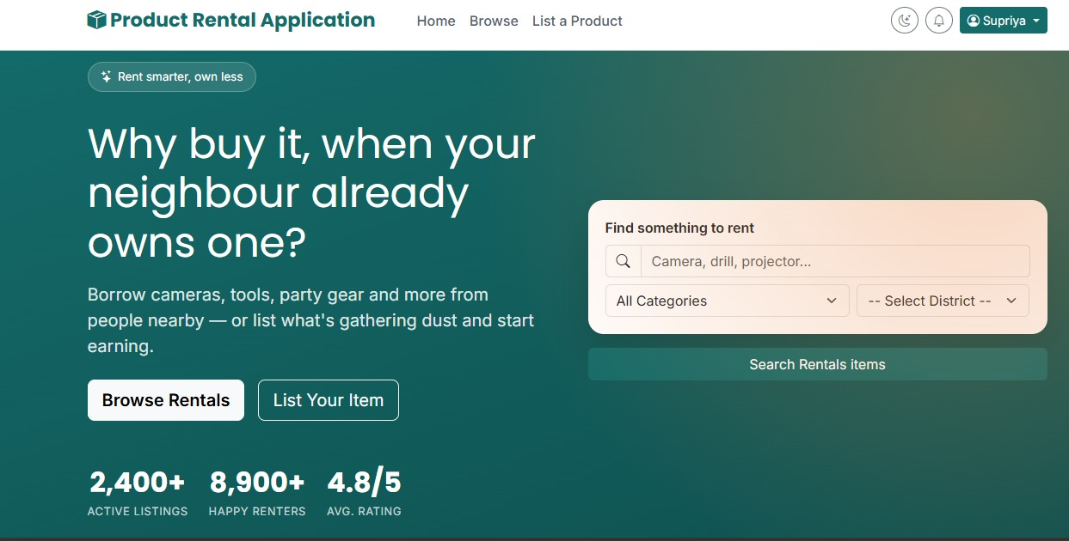

6.1.2 User registration page
The Registration Page allows new users to create an account by entering the required details.
The registration screen contains fields for user information and provides a registration option.
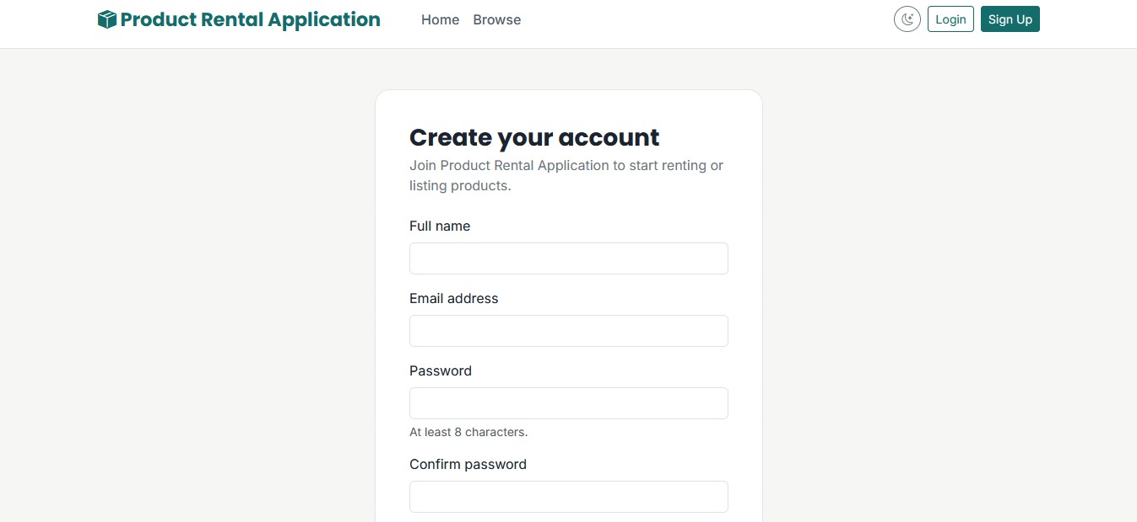

6.1.3 User login page
The Login Page allows registered users to access the application using their email and password.
After successful authentication, the user is redirected to the appropriate dashboard.
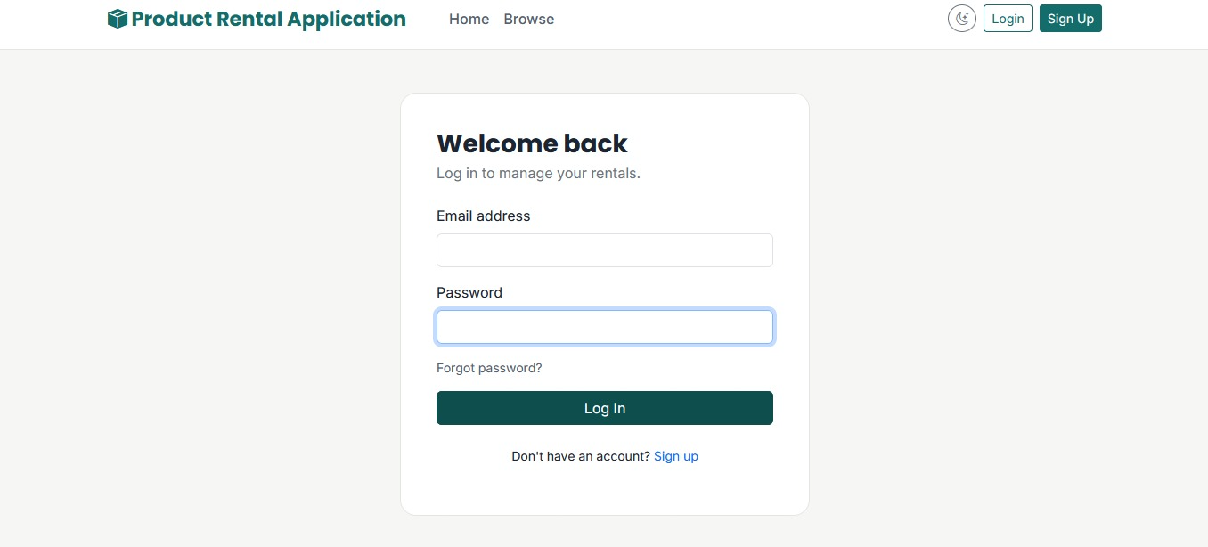

6.1.4 User dashboard
The User Dashboard provides access to the main functions available to the user.
It includes options such as:
- View Products
- Add Product
- Manage Products
- Rental Requests
- Wishlist
- Reviews and Ratings
- Notifications
- Complaints
- Profile
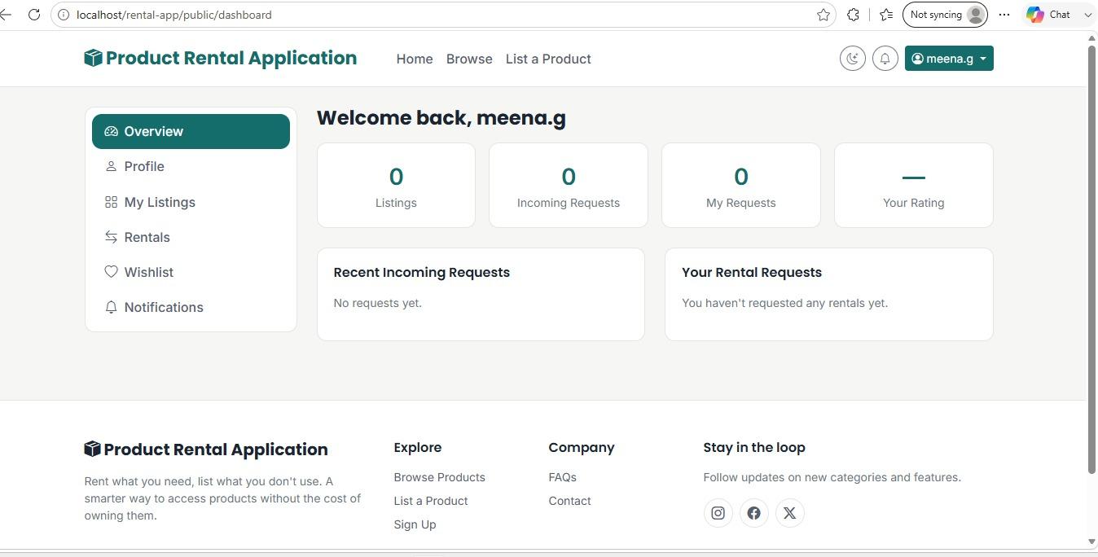

6.1.5 Product listing page
The Product Listing Page displays the products available for rental.
Users can view product information and select a product to see its complete details.
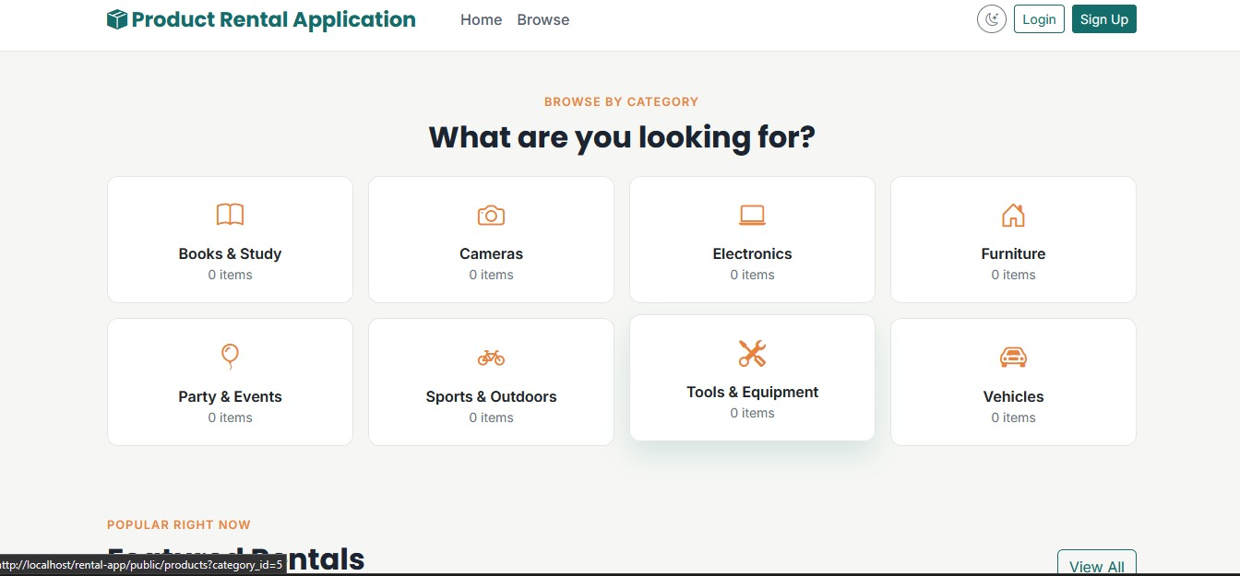

6.1.6 Product search and filter page
The application provides search and filtering options to help users find suitable products.
Products can be filtered based on:
- Keyword
- Category
- District
- Minimum Price
- Maximum Price
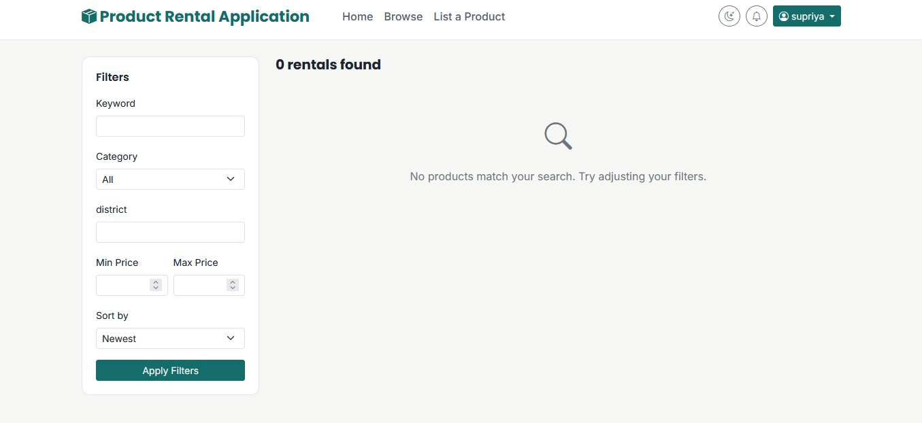

6.1.7 Product details page
The Product Details Page displays complete information about a selected product.
It includes details such as:
- Product title
- Description
- Category
- Rental price
- Rental unit
- Deposit
- District
- Product images
- Availability
Users can proceed with a rental request from this page.
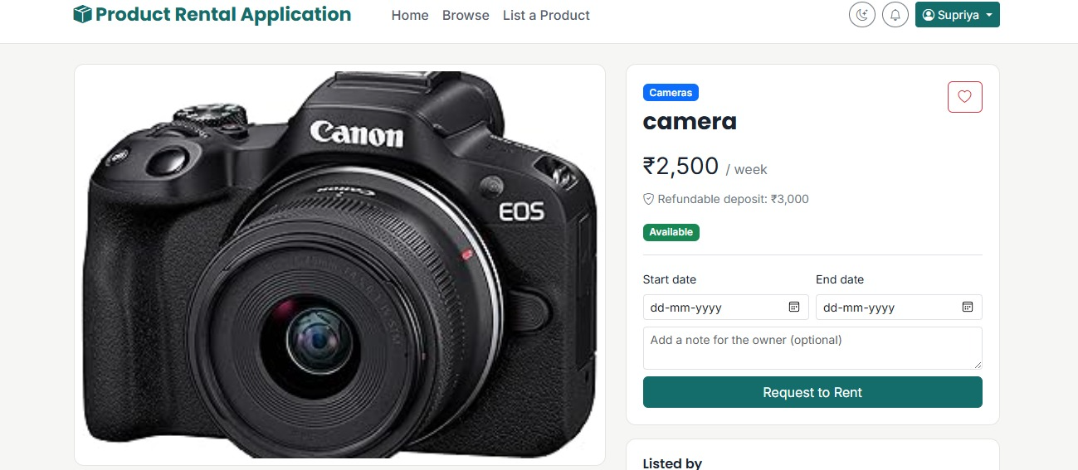

6.1.8 Add product page
The Add Product Page allows users to list their products for rental.
Users can enter product details, select a category, specify rental price and deposit, provide the district and upload product images.

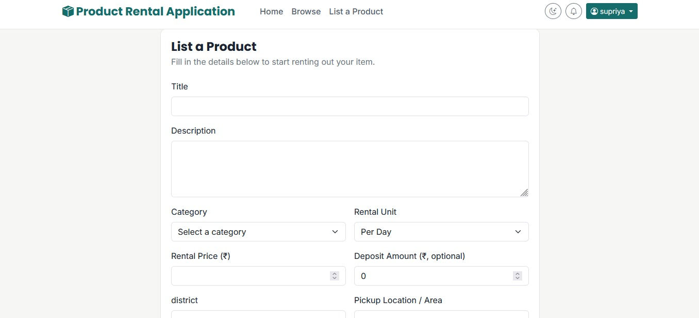

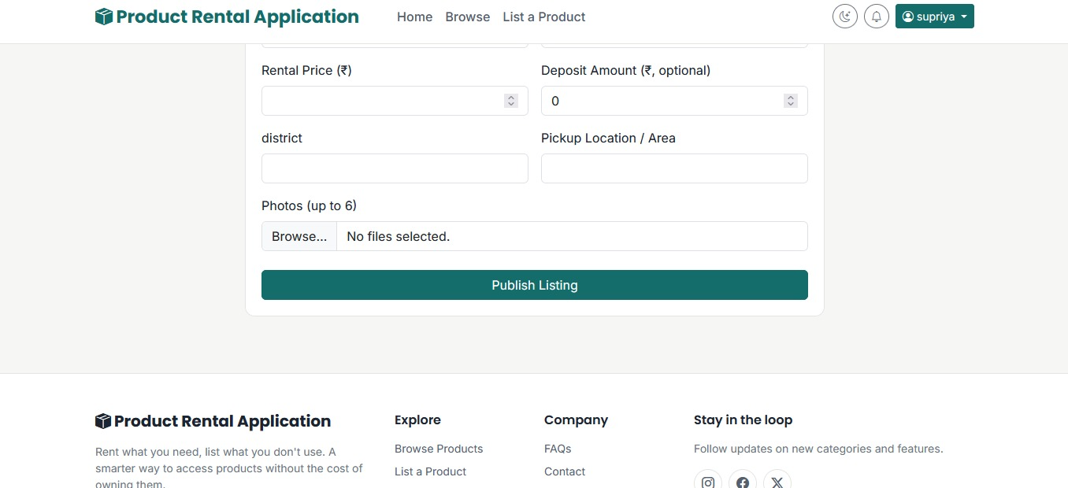

6.1.9 Rental request page
The Rental Request Page allows users to select the required rental period and submit a rental request.
The system records the request and sends it for processing by the product owner.
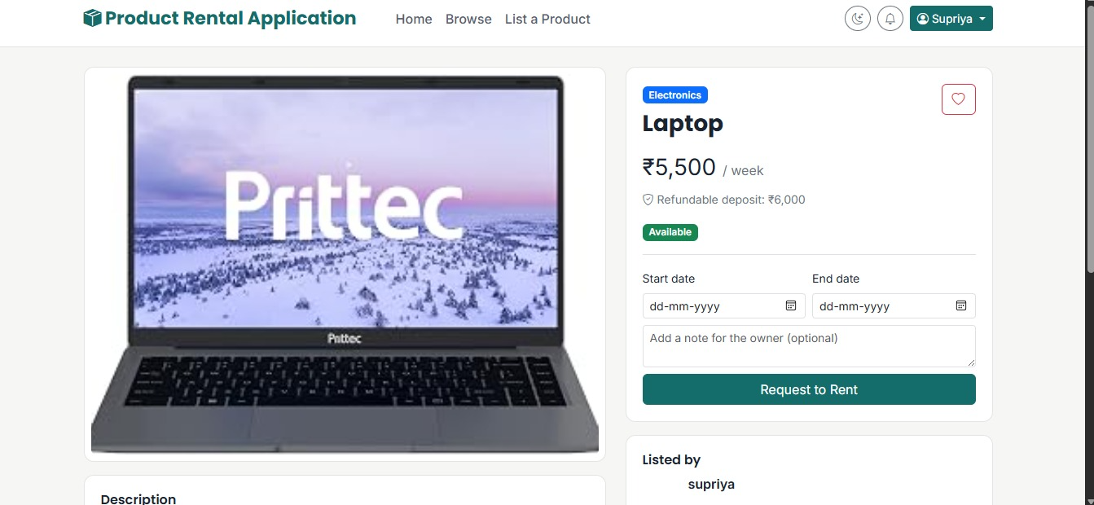

6.1.10 Rental management page
The Rental Management Page displays rental requests and their current status.
The rental status can include:
- Pending
- Accepted
- Rejected
- Completed
- Cancelled

6.1.11 Wishlist page
The Wishlist Page displays products saved by the user.
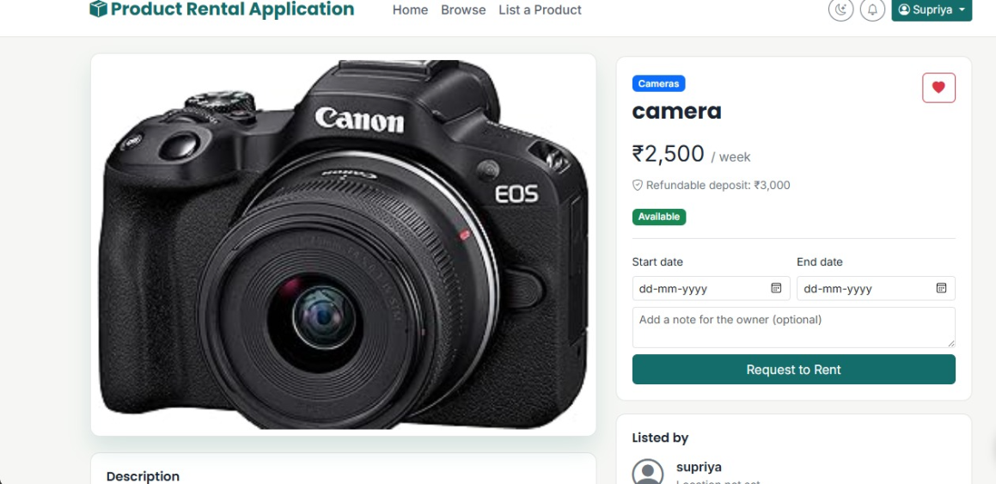

6.1.12 Review and rating page
The Review and Rating Page allows users to provide feedback after completing a rental.
Users can submit a rating and comment based on their rental experience.
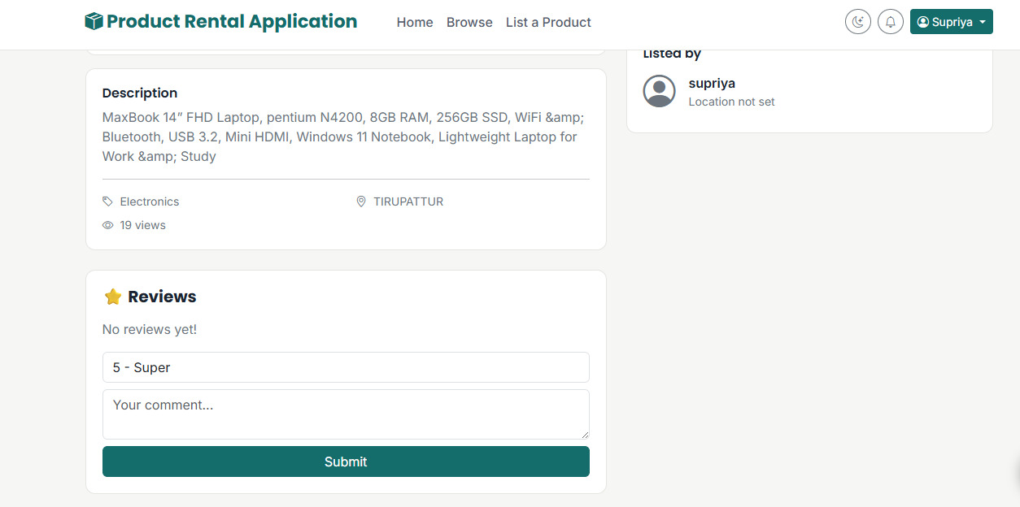

6.1.13 Notification page
The Notification Page displays important notifications related to rental activities and other system events.

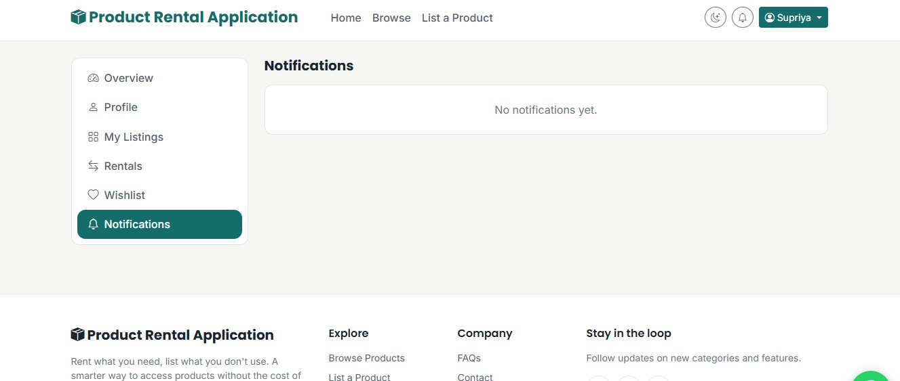

6.1.14 Complaint page
The Complaint Page allows users to submit complaints related to products or other users.
Users can provide the complaint subject and description.
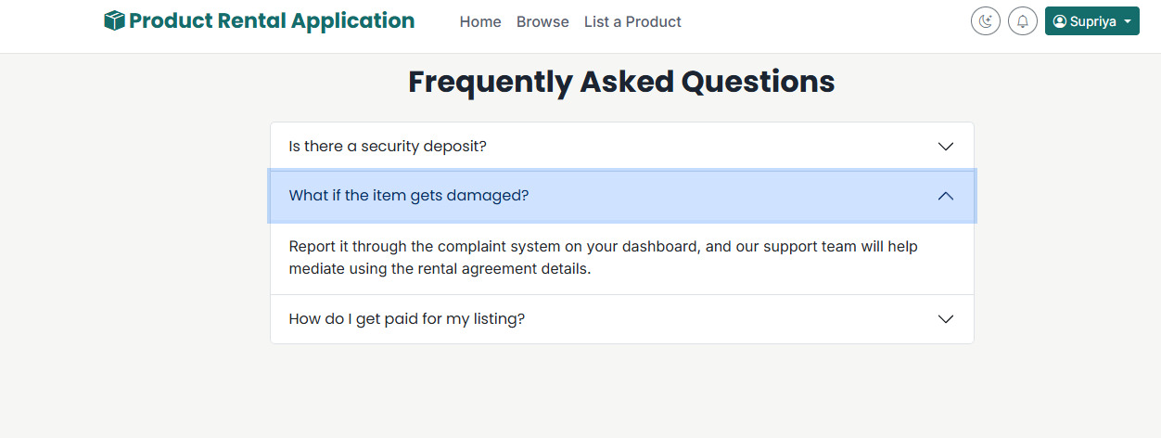

6.1.15 Admin dashboard
The Admin Dashboard provides centralized control over the Product Rental Application.
The administrator can access and manage:
- Users
- Products
- Categories
- Rentals
- Complaints
- Site Settings

6.2 SOURCE CODE
<!-- ============ HERO ============ -->
<section class="hero-section">
<div class="container position-relative">
<div class="row align-items-center g-5">
<div class="col-lg-6 text-white">
<span class="hero-badge mb-3"><i class="bi bi-stars"></i> Rent smarter, own less</span>
<h1 class="fw-display fw-800 display-5 mt-3 mb-3">Why buy it, when your neighbor already owns one?</h1>
<p class="fs-5" style="color: rgba(255,255,255,.85);">Borrow cameras, tools, party gear and more from people nearby &mdash; or list what's gathering dust and start earning.</p>
<div class="d-flex gap-3 mt-4">
<a href="<?= BASE_URL ?>/products" class="btn btn-light btn-lg fw-semibold">Browse Rentals</a>
<a href="<?= BASE_URL ?>/products/create" class="btn btn-outline-light btn-lg">List Your Item</a>
</div>
<div class="d-flex gap-4 mt-5">
<div class="stat-block"><div class="num">2,400+</div><div class="label">Active Listings</div></div>
<div class="stat-block"><div class="num">8,900+</div><div class="label">Happy Renters</div></div>
<div class="stat-block"><div class="num">4.8/5</div><div class="label">Avg. Rating</div></div>
</div>
</div>
<div class="col-lg-6">
<div class="hero-search">
<form action="<?= BASE_URL ?>/products" method="GET">
<label class="form-label fw-semibold text-dark">Find something to rent</label>
<div class="input-group mb-2">
<span class="input-group-text bg-white"><i class="bi bi-search"></i></span>
<input type="text" name="q" class="form-control" placeholder="Camera, drill, projector...">
</div>
<div class="row g-2">
<div class="col-7">
<select name="category_id" class="form-select">
<option value="">All Categories</option>
<?php foreach ($categories as $cat): ?>
<option value="<?= $cat['id'] ?>"><?= htmlspecialchars($cat['name']) ?></option>
<?php endforeach; ?>
</select>
</div>
<div class="col-5">
<select name="District" class="form-select" required>
<option value="">-- Select District --</option>
<option value="Chennai">Chennai</option>
<option value="Coimbatore">Coimbatore</option>
<option value="Madurai">Madurai</option>
<option value="Tiruchirappalli">Tiruchirappalli</option>
<option value="Salem">Salem</option>
<option value="Tirunelveli">Tirunelveli</option>
<option value="Erode">Erode</option>
<option value="Vellore">Vellore</option>
<option value="Thanjavur">Thanjavur</option>
<option value="Dindigul">Dindigul</option>
<option value="Thoothukudi">Thoothukudi</option>
<option value="Kancheepuram">Kancheepuram</option>
<option value="Cuddalore">Cuddalore</option>
<option value="Sivaganga">Sivaganga</option>
<option value="Virudhunagar">Virudhunagar</option>
<option value="Ramanathapuram">Ramanathapuram</option>
<option value="Nagapattinam">Nagapattinam</option>
<option value="Namakkal">Namakkal</option>
<option value="Dharmapuri">Dharmapuri</option>
<option value="Krishnagiri">Krishnagiri</option>
<option value="Karur">Karur</option>
<option value="Perambalur">Perambalur</option>
<option value="Ariyalur">Ariyalur</option>
<option value="Pudukkottai">Pudukkottai</option>
<option value="Theni">Theni</option>
<option value="Nilgiris">Nilgiris</option>
<option value="Tiruppur">Tiruppur</option>
<option value="Tiruvallur">Tiruvallur</option>
<option value="Tiruvannamalai">Tiruvannamalai</option>
<option value="Tiruvarur">Tiruvarur</option>
<option value="Viluppuram">Viluppuram</option>
<option value="Kanyakumari">Kanyakumari</option>
<option value="Chengalpattu">Chengalpattu</option>
<option value="Kallakurichi">Kallakurichi</option>
<option value="Mayiladuthurai">Mayiladuthurai</option>
<option value="Ranipet">Ranipet</option>
<option value="Tenkasi">Tenkasi</option>
<option value="Tirupathur">Tirupattur</option>
</select>
</div>
</div>
</div>
<button type="submit" class="btn btn-primary w-100 mt-3">Search Rentals items</button>
</form>
</div>
</div>
</div>
</div>
</section>

<!-- ============ CATEGORIES ============ -->
<section class="container py-5">
<div class="text-center mb-4">
<span class="section-eyebrow">Browse by category</span>
<h2 class="fw-display fw-bold mt-2">What are you looking for?</h2>
</div>
<div class="row g-3">
<?php foreach ($categories as $cat): ?>
<div class="col-6 col-md-3">
<a href="<?= BASE_URL ?>/products?category_id=<?= $cat['id'] ?>" class="category-card d- block text-decoration-none">
<i class="bi <?= htmlspecialchars($cat['icon']) ?> d-block mb-2"></i>
<div class="fw-semibold text-body"><?= htmlspecialchars($cat['name']) ?></div>
<div class="small text-secondary"><?= (int) $cat['product_count'] ?> items</div>
</a>
</div>
<?php endforeach; ?>
</div>
</section>

<!-- ============ FEATURED PRODUCTS ============ -->
<section class="container py-4">
<div class="d-flex justify-content-between align-items-end mb-4">
<div>
<span class="section-eyebrow">Popular right now</span>
<h2 class="fw-display fw-bold mt-2">Featured Rentals</h2>
</div>
<a href="<?= BASE_URL ?>/products" class="btn btn-outline-primary">View All</a>
</div>
<div class="row g-4">
<?php if (empty($featuredProducts)): ?>
<p class="text-secondary">No listings yet &mdash; be the first to list a product!</p>
<?php endif; ?>
<?php foreach ($featuredProducts as $p): ?>
<div class="col-6 col-md-4 col-lg-3">
<div class="product-card h-100 position-relative">
<a href="<?= BASE_URL ?>/products/<?= $p['id'] ?>" class="text-decoration-none text-body">
<div class="img-wrap">
<?php if ($p['thumbnail']): ?>
<img src="<?= UPLOAD_URL_PRODUCTS . htmlspecialchars($p['thumbnail']) ?>" alt="<?= htmlspecialchars($p['title']) ?>">
<?php else: ?>
<div class="d-flex align-items-center justify-content-center h-100 text-secondary"><i class="bi bi-image fs-1"></i></div>
<?php endif; ?>
</div>
<div class="p-3">
<div class="small text-secondary mb-1"><?= htmlspecialchars($p['category_name']) ?></div>
<h6 class="fw-semibold text-truncate mb-1"><?= htmlspecialchars($p['title']) ?></h6>
<div class="price-tag">&#8377;<?= number_format($p['rental_price'], 0) ?> <span class="fw-normal small text-secondary">/ <?= str_replace('per_', '', $p['rental_unit']) ?></span></div>
</div>
</a>
</div>
</div>
<?php endforeach; ?>
</div>
</section>
<!-- ============ HOW IT WORKS ============ -->
<section class="container py-5">
<div class="text-center mb-5">
<span class="section-eyebrow">Simple process</span>
<h2 class="fw-display fw-bold mt-2">How Product Rental Application Works</h2>
</div>
<div class="row g-4 text-center">
<div class="col-md-4">
<i class="bi bi-search fs-1 text-primary-brand mb-3 d-block"></i>
<h5 class="fw-semibold">Find it</h5>
<p class="text-secondary">Search nearby listings by category, price, or location.</p>
</div>
<div class="col-md-4">
<i class="bi bi-calendar-check fs-1 text-primary-brand mb-3 d-block"></i>
<h5 class="fw-semibold">Book it</h5>
<p class="text-secondary">Send a rental request with your dates. Owners confirm availability.
</p>
</div>
<div class="col-md-4">
<i class="bi bi-box-seam fs-1 text-primary-brand mb-3 d-block"></i>
<h5 class="fw-semibold">Use it, return it</h5>
<p class="text-secondary">Pick up, use, return &mdash; then leave a review for the community.
</p>
</div>
</div>
</section>
<!-- ============ TESTIMONIALS ============ -->
<section class="container py-5">
<div class="text-center mb-4">
<span class="section-eyebrow">Community voices</span>
<h2 class="fw-display fw-bold mt-2">What renters are saying</h2>
</div>
<div class="row g-4">
<div class="col-md-4">
<div class="testimonial-card h-100">
<div class="text-warning mb-2"><i class="bi bi-star-fill"></i><i class="bi bi-star-fill"></i><i class="bi bi-star-fill"></i><i class="bi bi-star-fill"></i><i class="bi bi-star-fill"></i></div>
<p>"Rented a DSLR for a weekend trip instead of buying one. Saved a huge amount and the owner was super responsive."</p>
<div class="fw-semibold small">— Dhana,Tirupattur</div>
</div>
</div>
<div class="col-md-4">
<div class="testimonial-card h-100">
<div class="text-warning mb-2"><i class="bi bi-star-fill"></i><i class="bi bi-star-fill"></i><i class="bi bi-star-fill"></i><i class="bi bi-star-fill"></i><i class="bi bi-star-fill"></i></div>
<p>"I listed my drill set that was sitting unused for years. Now it pays for itself every few months."</p>
<div class="fw-semibold small">— Supriya, Tirupattur</div>
</div>
</div>
<div class="col-md-4">
<div class="testimonial-card h-100">
<div class="text-warning mb-2"><i class="bi bi-star-fill"></i><i class="bi bi-star-fill"></i><i class="bi bi-star-fill"></i><i class="bi bi-star-fill"></i></div>
<p>"Booking was simple and the request/approval flow made everything feel safe and organized."</p>

7. TESTING
Testing is an important phase in the development of the Product Rental Application. It is performed to identify errors, verify system functionality and ensure that the application works according to the specified requirements. The major modules of the application are tested to ensure reliability, security, performance, usability and compatibility.
7.1 Test plan
The Test Plan describes the testing approach used for the Product Rental Application. Testing is performed on the major modules and functions of the system.
The objectives of the test plan are:
- To verify that all major functions work correctly.
- To identify and correct errors in the application.
- To verify database operations.
- To check user login and authentication.
- To verify product and rental management.
- To ensure that the application is easy to use.
- To verify the compatibility of the application on different browsers and devices.
7.2 Scope of testing
The scope of testing covers the major functional and non-functional aspects of the Product Rental Application.
The following areas are included in testing:
- User Registration and Login
- User Profile Management
- Product Management
- Product Search and Filtering
- District-wise Product Search
- Rental Request Management
- Wishlist Management
- Review and Rating
- Notification Management
- Complaint Management
- Database Operations
- Security

7.3 Test case
Test cases are prepared to verify the expected behaviour of the application. Each test case contains the input, expected result and actual result.
Test Case ID | Module | Test Case | Expected Result | Status
TC01 | Registration | Enter valid user details | User account should be created | Pass
TC02 | Login | Enter valid email and password | User should login successfully | Pass
TC03 | Login | Enter incorrect password | Error message should be displayed | Pass
TC04 | Product | Add a valid product | Product should be added successfully | Pass
TC05 | Product | Edit product details | Product details should be updated | Pass
TC06 | Search | Search for a product Matching | products should be displayed | Pass
TC07 | Filter | Filter by category/district/price | Relevant products should be displayed | Pass
TC08 | Rental | Submit rental request | Request should be created | Pass
TC09 | Rental | View rental status | Current status should be displayed | Pass
TC10 | Wishlist | Add product to wishlist | Product should be added | Pass
TC11 | Review | Submit rating and review | Review should be saved | Pass
TC12 | Complaint | Submit complaint | Complaint should be recorded | Pass
TC13 | Admin | Login as administrator | Admin dashboard should open | Pass
TC14 | Logout | Click logout | User session should end | Pass

7.4 Functional testing
Functional Testing verifies whether the functions of the Product Rental Application work according to the specified requirements.

The following functions are tested:
- User registration
- User login and logout
- Product addition and management
- Product search
- Category and district filtering
- Rental request submission
- Rental status management
- Wishlist operations
- Review and rating
- Notifications
- Complaint submission
- Administrator functions
The functional testing confirms that the major functions of the application produce the expected results.
7.5 Security testing
Security Testing is performed to ensure that the application and user data are protected from unauthorized access.
The following security aspects are tested:
- User authentication
- Password protection
- Session management
- Authorization for administrator functions
- Input validation
- Protection against unauthorized access
- Secure database operations
- File upload validation
Security testing helps protect user information and prevents unauthorized users from accessing restricted functions.
7.6 Performance testing
Performance Testing is performed to evaluate the response and efficiency of the Product Rental Application.
The following areas are tested:
- Page loading time
- Login response
- Product search response
- Product filtering response
- Database query response
- Rental request processing
- Dashboard loading
The application should provide a reasonable response time while handling normal user activities.
7.7 Usability testing
Usability Testing evaluates how easily users can understand and use the Product Rental Application.
The following aspects are tested:
- Simple navigation
- Clear page layout
- Easy-to-understand buttons and labels
- Easy product searching
- Simple rental request process
- Clear rental status
- User-friendly forms
- Readable content
- Easy access to important functions
The testing confirms that the application provides a simple and user-friendly interface.

7.8 Compatibility testing
Compatibility Testing verifies whether the Product Rental Application works properly on different web browsers, screen sizes and devices.
The application can be tested using:
- Google Chrome
- Microsoft Edge
- Mozilla Firefox
- Desktop computers
- Laptops
- Mobile screen sizes
The purpose of compatibility testing is to ensure that the application's layout and major functions remain usable across different environments.

8. BIBLIOGRAPHY

[1]. Shroff, H., Joshi, S., Khandelwal, K., Arutwar, R., Dedgaonkar, S., & Bhimanpallewar, R. (2025). Web-based Rental Application for Leasing and Renting Daily Utilities. Journal of Computer Technology & Applications, Volume 16, Issue 01, pp. 77–83
[2]. Kathir, K., Lakshmanan, K., Deebanchakkarawarthi, G., Sathya, S., Nithish, R., Indravarma, K. S., & Muthupandi, T. (2025). Online Rental Management System – RentalEaze. International Journal of Scientific Research in Engineering and Management, Volume 09, Issue 11, pp. 1–9. DOI: 10.55041/IJSREM53388.
[3]. Ariestian, M., & Arnomo, S. A. (2025). Rancang Bangun Aplikasi Rental Perangkat Elektronik Berbasis MERN. Computer Based Information System Journal, Volume 13, Issue 1, pp. 93–102. DOI: 10.33884/cbis.v13i1.9631.
[4]. Owen, I., & Fitrisia, I. (2025). Heavy Equipment Rental Information System Development using the Prototyping Method. Journal of Applied Informatics and Computing, Volume 9, Issue 2, pp. 475–482.
[5]. Chalim, A., Surendro, K., & Kaleb, B. J. (2025). Pengembangan Sistem Informasi Rental Peralatan Elektronik Berbasis Web. Jurnal Sistem Informasi Bisnis, Volume 6, Issue 2, pp. 302–313.
[6]. Rachmat, F. M., Mawardi, C., & Pradana, Y. (2026). Manake Media Equipment Rental System with Payment Gateway and Business Process Optimization. International Journal of Computer and Information System, Volume 7, Issue 2, pp. 61–70. DOI: 10.29040/ijcis.v7i2.269.
[7]. Mogili, U., Sharmila, I., Manga, S., Padma, G., Nandini, M., & Dileep, P. (2026). A Web-Based Smart Rental Management System Using React and Secure Payment Integration. International Journal of Innovative Research in Technology, Volume 12, Issue 10, pp. 5847–5854.
[8]. Naik, R. N., Parida, P. S., & Ray, J. (2026). Design and Implementation of Home Deal: A Web-Based House Rental Management System. International Journal of AI EBiomedicine Innovations, Volume 2, Issue 2, pp. 80–88.
[9]. Verma, R. (2025). Design and Implementation of a Web-Based Smart House Rental Application for Urban Communities. International Journal of Trend in Scientific Research and Development, Special Issue, March 2025, pp. 1210–1214.

9. CONCLUSION

The Product Rental Application has been successfully designed and developed as a web-based platform for renting products in a simple and convenient manner. The application provides an organized environment where users can browse available products, view product details, search and filter products based on category, price and district, and submit rental requests.The system includes important features such as user registration and login, product management, rental request management, wishlist, reviews and ratings, notifications, complaint management and administrator management. The use of PHP, MySQL, HTML, CSS, JavaScript, Bootstrap and XAMPP provides the required environment for developing and managing the application.The testing phase was performed to verify the functionality, security, performance, usability and compatibility of the system. The test results confirm that the major functions of the application work as expected.Overall, the Product Rental Application provides a simple, efficient and user-friendly solution for product rental management. It reduces the difficulties involved in traditional rental processes and provides a structured platform for connecting users with available rental products. The system can also be enhanced in the future by adding additional features such as online payment, GPS-based search, real-time chat and mobile application support.

